Skill Week-6
Session-11
Task 1: To Store Commands, Maintain History Buffer, Handle Capacity Limits, Retrieve Entries, Display History, Validate Consistency
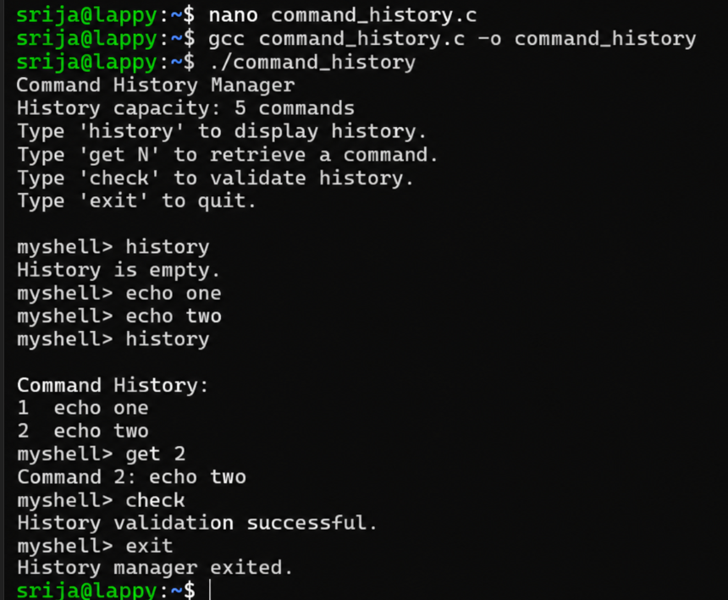
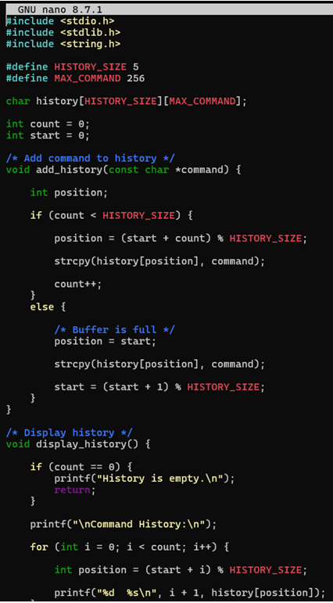
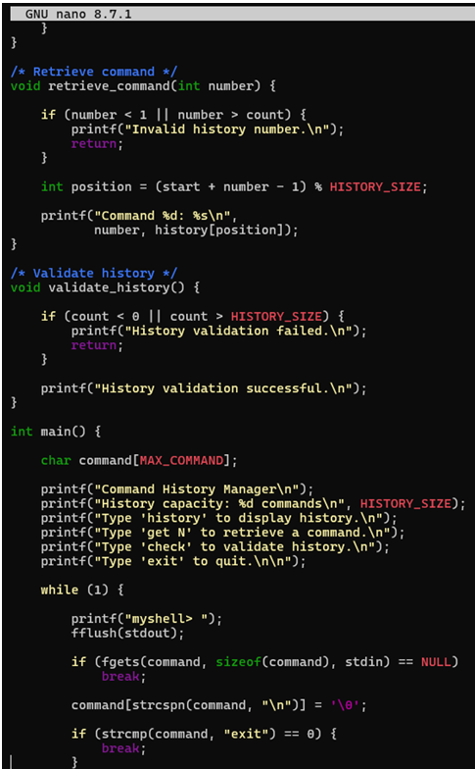\
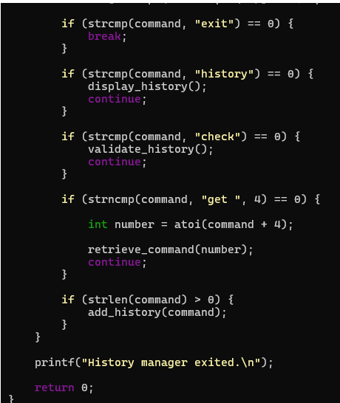
Task 2: To Create Pipeline Structures, Store Commands, Maintain Execution Order, Connect Processes, Validate Pipeline Layout, Test Configurations
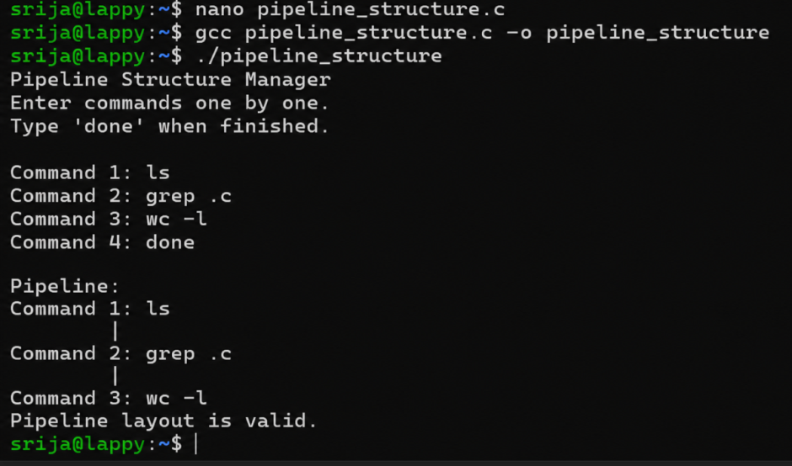
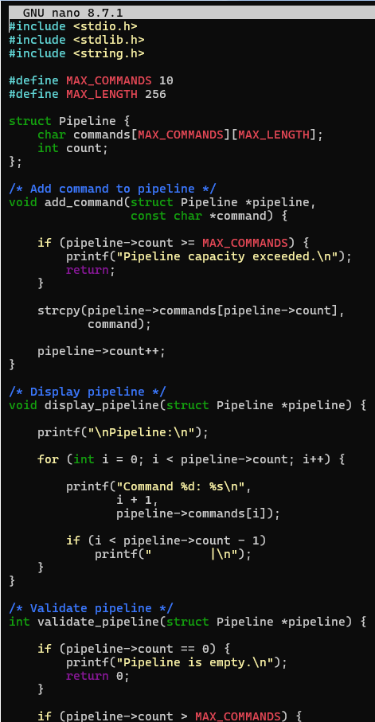
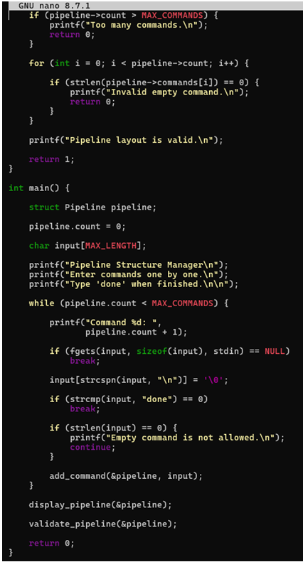
Session-12
Task 1:To Create Pipes, Redirect Streams, Execute Connected Commands, Close Descriptors, Synchronize Processes, Test Data Flow
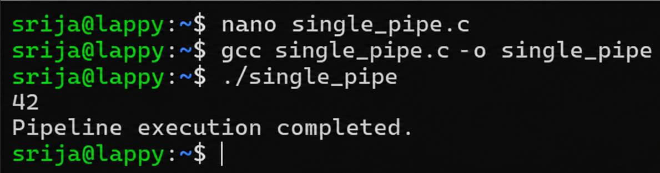
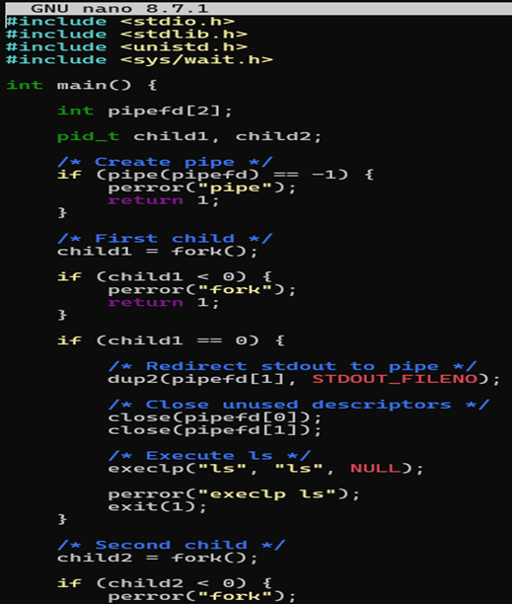
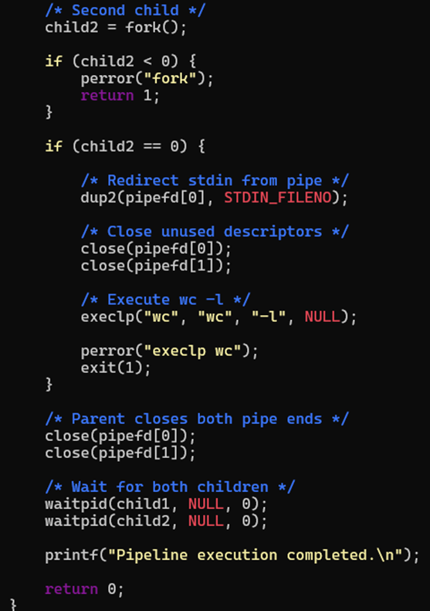
Task 2:To Support Multiple Pipes, Manage Descriptor Arrays, Launch Multiple Processes, Coordinate Execution, Cleanup Resources, Test Long Pipelines
